Renju lesson on December 21, 2000

Hello all! We can begin the lesson. I am happy to see that 22 people studied hard last week and did the homework. I also know that the homework was not easy and several people made some mistakes. Some students perhaps understand their mistakes, some don’t. However, I wish that everyone would know what went wrong in their homework, therefore I write my comments to those hw answers.
Lets begin now. I wish to begin with new opening today. We have already discussed all important variants of d3 opening. If anyone of you still has some questions about d3, please send your question to me in renlib file, and I will answer and post the answer to download area of the website and you can go and get it there.
Today’s topic is d8 opening. Opening d8 is one of the three most popular openings. Do you know the names of those three popular openings? That’s right. Openings d3, d8 and d11 are really popular recently. We have already studied d11 opening (5lin) and d3 opening (playsite), and now it is time to learn about d8. In my opinion, black has about 75% advantage in d8 opening. That is why players tend to swap sides when someone sets d8 in the game. There is only one good 4th move, any other 4th move gives black too big advantage or even win. Where is that 4th move? Indeed, h6 is the right one. Lets play it. Speaking of 5th moves, who can name all the possible 5th moves here? You can use your knowledge, or even just guess.
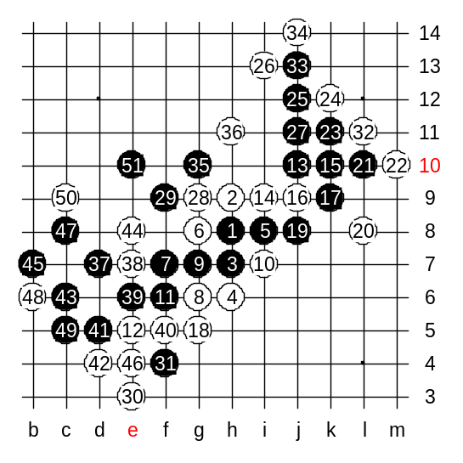
I have seen people playing 5th moves h10, i10, i9, j9, i8, j8. Some of them are good, some of them are weak. Lets try to evaluate them. Which move gives black win? Yes, i8 is black win. It is really complicated win, and takes lots of time to learn. By the way, is move 5-i7 same as 5-i8? Indeed, there is small edge related difference. Well, when I played the match with Nakamura, I set 5-i7 as one choice on the board (together with 5-i6). If I had offered 5-i8, then he would have removed it immediately and continued with 5-i6. But now, he used 30 minutes of his thinking time to try to figure out if the edge distance influences the win in case of 5-i7. Finally, either having no sure conclusion, or just being afraid of trap, he removed my 5-i7 offer. The tactics of mine was to force him think and spend his thinking time on clock.
We will not learn 5-i7 with you. We will learn 5-i8, and then everyone can try to test those positions with 5-i7 and see the problems and differences. We will play 5-i8 now. The strongest 6th move is g8.
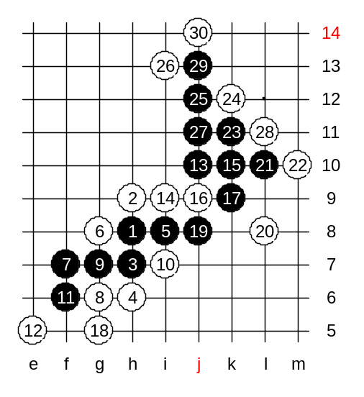
White has some choices for 8th move, but they all seem to lose sooner or later. Actually, Nakamura is one of the best experts of those variants. I think he may know these variants better than me. We begin with 8-g8. Now, I give you chance to direct the attack for a while. Lets see for how long you can show the right moves. There is only one good 13th move. Don’t miss it. Those who said j10 are right. The idea of that move is to develop towards right side space and prepare the attacking base there. The next move is k10. Now white seems to have 3x3 at k9, is it dangerous? Right, white will lose in that case. I will show you the next moves myself, and try to explain some difficult parts. Now we have 27 stones on board, lets take a look at the situation. If white would play i11 now, how can black win? Good, you found it. White has to play g9 and e3 now, and then block from L11. By the way, it is good to know that in case of 5-i7 black cannot use similar attack because then white could block 28-i11 and since there would be one line less, the win with m11, L11, L12, j14 would not work. Move 35 – the key move of the variant. Where is it? Move g10 is the key to win – although it creates an overline structure, it doesn’t bother black at all. Moves d7 and e6 prepare the left side attack. Now, black wins, no matter how white defends. After 47th move, what can white do? Black wins by the 51st move.

Medium level homework: Please find the black win.

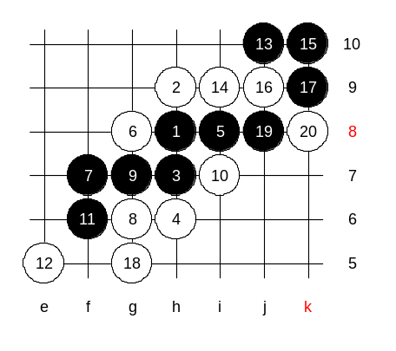
Advanced level homework:
Please find the black win.

The lesson is over now. Thank you all for coming, see you again next week. Merry Christmas to all of you!!

